Session-1 Database
- Install MySQL Workbench on your computer, connect to the local MySQL server, and take a screenshot of the default databases shown in the Schemas panel.
Ans.
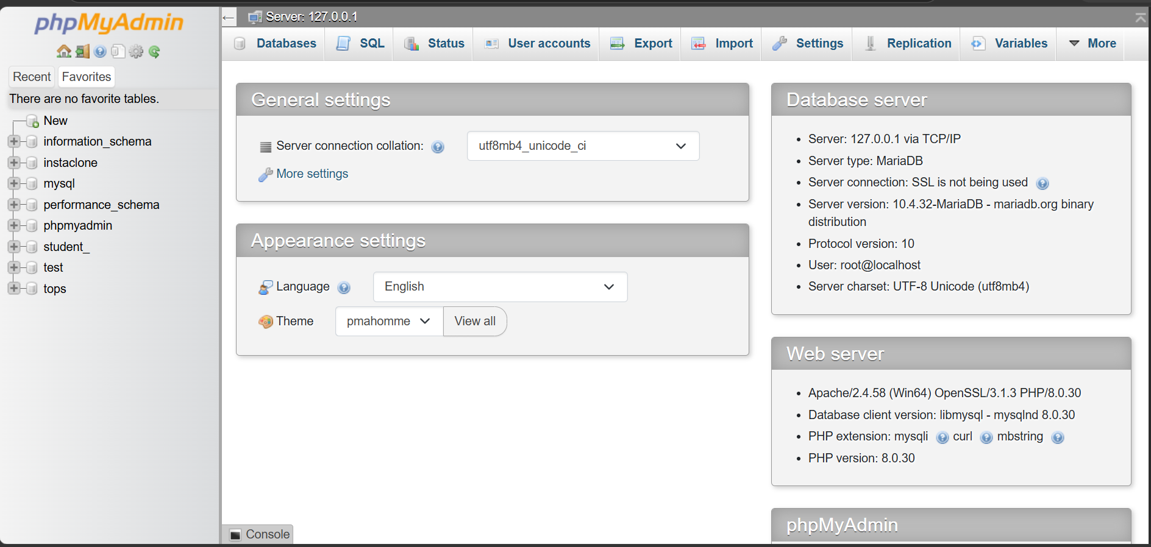

- Create a new database called InstaClone in MySQL Workbench, then create a table named Users with columns: user_id (INT, primary key), username (VARCHAR), email (VARCHAR), and followers_count (INT).
Ans.
CREATE DATABASE InstaClone;
USE InstaClone;
CREATE TABLE Users (
user_id INT PRIMARY KEY,
username VARCHAR(50),
email VARCHAR(100),
followers_count INT
);

- Insert 3 sample users into the Users table you created, using
realistic Instagram-style usernames and follower counts.
Ans.

INSERT INTO Users (user_id, username, email, followers_count)
VALUES
(1, 'rahul_01', 'rahul01@gmail.com', 1200),
(2, 'priya_official', 'priya@gmail.com', 3500),
(3, 'travel_with_amit', 'amit@gmail.com', 5800);
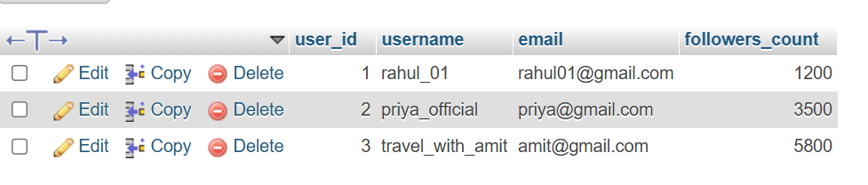

- Create another table in the InstaClone database called Posts with columns: post_id (INT, primary key), user_id (INT), caption (VARCHAR), and post_date (DATE). Add a foreign key from Posts.user_id to Users.user_id to establish a relationship.
Ans.
CREATE TABLE Posts (
post_id INT PRIMARY KEY,
user_id INT,
caption VARCHAR(255),
post_date DATE,
FOREIGN KEY (user_id) REFERENCES Users(user_id)
);
INSERT INTO Posts (post_id, user_id, caption, post_date)
VALUES
(101, 1, 'Sunset at Beach ', '2026-07-10'),
(102, 2, 'Enjoying rainy weather ', '2026-07-11'),
(103, 3, 'coffee time ', '2026-07-12');
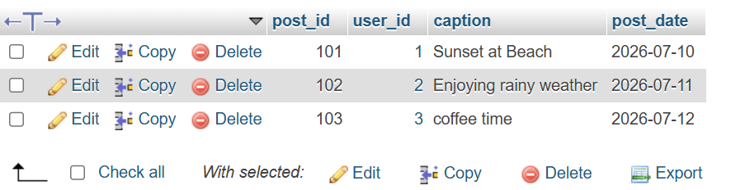

- Write a short comparison (3-4 lines each) of MySQL, PostgreSQL, Oracle, and SQLite, focusing on where each one is commonly used (for example: web apps, mobile apps, enterprise systems, etc.).
Ans.
SELECT
Users.username,
Posts.caption,
Posts.post_date
FROM Users
INNER JOIN Posts
ON Users.user_id = Posts.user_id;
